
Ajman University
College of Engineering and Information Technology Department of Information Technology
SAKNA - A House Building Web Platform for the United Arab Emirates

- Students Name:
- Haya Al mujbber | 202010926 | IS/Project Management
- Rauda Hamdan | 202020170 | IS/E-Business Management
- Nada Farajallah | 202010823 | IS/project Management

Supervised by:

Dr. Shafiz A Mohd Yusof
Project Submitted in partial fulfillment for the degree of Bachelor of Information Systems

Spring-Semester-2024

Acknowledgement

As members of this group, we would like to take this opportunity to sincerely thank Dr. Shafiz Yusof, our supervisor, for his tremendous experience and unwavering support during this project. He is an example to all of us and his unwavering dedication and support have been crucial to the successful completion of this task.

We would like to take this opportunity to express our profound appreciation to Ajman University,
which provided us with the necessary equipment, space, and encouraging environment that enabled us to complete this project. In addition, this university has always supported academic quality and innovation, aspects of paramount importance during this development.
We would also like to thank our peers and colleagues for their so much helpful assistance, cooperation, and comments. Their contributions greatly enhanced the quality and result of our project.
Finally, we would like to express from the bottom of our hearts our deepest gratitude towards our
families and friends for their encouragement, understanding, and patience regarding everything. They had given us the strength to overcome obstacles and stay focused on the goal.
It is a team effort, really; we are very grateful to all of those who assisted us in winning.

Abstract
SAKNA is a web-based platform that will break through the construction industry in the United Arab
Emirates by making life easy for homeowners and project managers who seek the right professional for their construction projects. Created using Wix, SAKNA provides a single user interface that is easy to handle with special features such as the advanced contractor-matching system, cost estimation, the
project management interface, multi-lingual support, and localized regulatory guidelines for the UAE market.
SAKNA stands unique among other platforms because it will cover the needs of the UAE exclusively. It provides advanced search filters, user favorites, contractor galleries that are searchable, multilingual support, and region-specific permit guidelines. Using Wix tools and Velo will be a scalable way to
build this platform with flexibility and maintainability in mind, without complex server-side configurations.
Its major strengths involve the platform's localized approach, friendly user interface, multilingual capabilities, and advanced system for matching with contractors. However, this platform has tough
competitors globally. SAKNA is expected to develop an even better user and contractor experience by

incorporating technologies soon like AI, Machine Learning, and Virtual Reality and continue towards an even robust solution for UAE's construction industry.

List Of Abbreviation
Below is a list of abbreviations used throughout this project report.
List of Abbreviations
AJAX: Asynchronous JavaScript and XML AI: Artificial Intelligence
CSS: Cascading Style Sheets DOM: Document Object Model ER: Entity Relationship
HTML: Hypertext Markup Language HTTP: Hypertext Transfer Protocol JSON: JavaScript Object Notation SQL: Structured Query Language
SSL: Secure Socket Layer UAE: United Arab Emirates UI: User Interface
Velo: Wix's full-stack development platform

Table of Contents

Abstract 3
Chapter 1: Introduction 6
Project Name: SAKNA 6
  - Background 7
  - Motivation and Problem Statement 8
  - Objectives 8
  - Project Contributions 9
  - Documentation Overview 9
Chapter Two: Literature Review 11
  - Concept 1: Online Platforms for Construction Services 11
Key Features of Existing Online Construction Service Platforms: 11
  - Concept 2: Cost Estimation Tools 12
  - SWOT Analysis of SAKNA 12
  - Market Analysis 14
Chapter Three: Planning and Requirements 16
  - Project Scope 16
  - Project Scenarios and Plan 16
    - Roles and Responsibilities 16
    - Constraints 17
    - Risks 17
    - Project Management Approach 18
  - Requirements Gathering Techniques 18
  - Functional Requirements 18
  - Non-functional Requirements 21
Chapter Four: Planning and Requirements 22
  - Context diagram 22
  - Use case Diagram 22
  - Activity Diagram 23
  - Sequence Diagram 24
  - ER Diagram 25
  - User Interface Design 26
  - Architectural Design 27
  - Network Design 29
Chapter Five: Implementation 29
  - Environment 29
  - Evaluation and Testing Measures 29
    - Testing Goals 30
    - Testing Plans 31
    - Testing Methodologies 31
  - Implementation Schedule 31
Chapter Six: Conclusion 33
  - Strengths and Weaknesses 33
  - Improvements for the Future 34
  - Conclusion 34
Chapter Seven : References 35
Chapter Eight : Appendix 36
  - Running the System 36
    - Homeowner/project Manager Login 36
    - Professional login 36
  - Screenshots 37
    - Homepage 37
    - The sign in screen 38
. 38
    - Dashboard 39

Table of Figures
Figure 1: Context Diagram 23
Figure 2: use Case Diagram 24
Figure 3: Activity Diagram 25
Figure 4: Sequence Diagram 26
Figure 5: ER Diagram 27
Figure 6: Architectural Design 28
Figure 7: Homepage Screen 37
Figure 8: Sign in Screen 37
Figure 9: Dashboard 38
Figure 10: Sign in (constructor) 38
Figure 11: My Account 39

Chapter 1: Introduction

Project Name: SAKNA
SAKNA is an online web application designed to simplify the process of connecting potential homeowners and project managers with the right contractors, decorators, architects, and other professionals in the building and construction industry. The name SAKNA is derived from the intended core functionality of the application-- helping users match with the right builders and professionals to fit their project needs within the United Arab Emirates. The underlying meaning is the ease and preciseness with which users find professionals using a robust matching system powered by advanced filtering, real- time interaction, and personalized preferences.

Background
Construction in the UAE is an exponentially growing industry, driven by continuous and high demand for residential properties, mainly in urban cities such as Dubai and Abu Dhabi. This robust growth is highly attributed to the rapid population growth and economic development and an increase in governmental initiatives with regard to promoting infrastructural and housing projects.
The process of building residential properties is very stressful and overwhelming for homeowners and project managers as most of them lack the required knowledge in cost estimation, and understanding government policies and permits that may affect building and construction projects. Additionally, they often lack an effective channel to connect with skilled professionals to demystify this process as most professionals are scattered around different emirates.
In such cases, it becomes quite hard for the homeowners and the managers of projects to identify the kind of professionals required for a specific project, estimate the costs involved, or understand the permits and regulations that may affect their building projects. This creates a gap that begs the introduction of a centralized platform that simplifies this rather tiresome process of connecting homeowners and project managers, with reliable building and construction experts, decorators, contractors, architects’ companies, and other professionals, providing necessary government-related construction information and offering tools to manage various user projects and construction sites from a unified dashboard.
SAKNA attempts to bridge this gap by providing a user-friendly solution that will serve as a one-stop platform for all house-building needs in the UAE. This web app allows homeowners and project managers to:
    - Search for and connect with companies and professionals based on specific project needs, location, and budget.
    - Access tools for cost estimation, permit guidance, and project management.

    - Simplify the process of finding and hiring building professionals through real-time matching, detailed project images, and relevant client reviews.

Motivation and Problem Statement
The problem that SAKNA solves is the fragmentation and inefficiency of the current methods in connecting homeowners and project managers with building professionals. For example, currently, homeowners and project managers have to scramble through:
    - Identifying and selecting capable, reliable contractors, decorators and other professionals with relevant experience to a user project.
    - Estimating the costs of construction projects accurately.

    - Understanding complex local building regulations and navigating the permit processes.

    - Proficiently reviewing and comparing several service providers to find the most suitable provider for the client.
It is in light of all these problems that SAKNA tries to establish a one-stop, user-friendly service that simplifies the process of house-building. The objective is to exclude the inconvenience of managing multiple resources for a user and with one platform from which informed decisions can be made.
This project is highly important because it leverages a huge market gap that has not fully been exploited as there has not been a dedicated, comprehensive platform for those services combined so far in the UAE. SAKNA intends to enter the market and garner a large market share as construction and development are among the dynamically developing sectors in the UAE. This project will not only positively impact homeowners but also the construction community, as they will experience a higher profit margin as a direct result of increased clientele.

Objectives
The main objectives of the SAKNA platform are:

- Provide advanced search and filtering that make it easy for clients to find the right contractors and professionals according to location, type of service, and budget.
- Provide an interactive cost estimator that offers accurate financial estimates of a project based on project details such as size, completion time, and labor cost across different regions.
- Simplify the process of obtaining permits and following regulations by providing potential homeowners and project managers with updated information on legal requirements.

- Offer a reliable review and rating system to ensure homeowners and project managers can make informed choices based on previous user experiences.
- Support multilingual functionality to cater to a broader audience, offering services in both Arabic and English.
- Provide a mobile-friendly experience that supports usability and accessibility on all devices.

Project Contributions
The SAKNA project offers several unique contributions to the industry:

- Innovation in the search process- allowing users to find building professionals by highly specific criteria and personal preference makes decision-making far easier.
- Integration of a cost estimation tool, which is hardly found in similar platforms, enables users to accurately budget for their projects.
- Make compliance with regulations simpler by providing clear, accessible guidelines on permits and regulations. This reduces the time and effort required from the user.
- Localized Information: The platform will make access to emirate-specific information on regulations and permits easier as users try to keep up with local requirements.
- Full review system allows trust and transparency between service providers and clients to make the marketplace even more reliable.
- Multilingual support and mobile responsiveness: This ensures access to a wide variance in the number of users across geographical boundaries through different kinds of devices.
SAKNA looks toward updating and improving the approach to building and renovation by
consolidating those key services onto one platform, therefore benefiting the users and professionals alike.

Documentation Overview
This paper outlines the structure and flow of the project proposal for SAKNA in a way that will give an elaborate description from the very concept to the implementation and testing of such. The structure of this document is as follows:

- Chapter One: Introduction - In this chapter, the background, objectives, key contribution,
motivation behind the project, problem statement, and need for an efficient solution to match users with building professionals are all evinced through the SAKNA platform.
- Chapter Two: Literature Review - This is a review of the work done and the research in related fields in the domain of contractor matching systems, cost estimation tools, and project management
platforms. It also provides a critical view of the existing solutions, with comparison to the features and novelties introduced by SAKNA. All key concepts related to the project are explored in-depth.
- Chapter Three: Planning and Requirements - This section outlines the functional and non-
functional requirements of the SAKNA system. It includes user needs, the functionality of the system, and a project plan that contains scope, roles, responsibilities, and risk assessments. The planning also discusses methodology, for example, AGILE, to be followed in the development of the project.
- Chapter Four: Project Analysis and Design- This chapter deals with the project's technical design overview, covering context diagrams, use cases, and different design models such as activity, sequence, and ER diagrams. Other designs that will determine the architecture, network, and user interface of the system are also presented in this chapter.
- Chapter Five: Implementation - The focus of this section is on the environment and technologies to be used for realizing the project; these being HTML, JavaScript, MySQL Wix Code , JSON, among other development tools. Testing measures, goals, and plans are also discussed in this section, while an explicit schedule for deploying the SAKNA platform is also outlined.
- Chapter Six: Conclusion - This last chapter deals with strengths and weaknesses found within the project and suggestions that could be used to improve the outcome in the future. The conclusion
reiterates the overall achievements and contributions of the project.

- References - A complete list of sources and documents consulted in support of this proposal and research for the SAKNA project.
- Appendix: The addition of supportive information, like inclusions of screenshots of the proposed SAKNA platform to be developed, with featured, proposed features and functionality will give further pictorial references to the design of the system and the user interface.

Chapter Two: Literature Review
This chapter explores and discusses the literature review and work conducted so far on online platforms for construction services, contractor matching systems, and project management tools. These concepts and their application to the SAKNA online platform. These concepts and their application to SAKNA will be analyzed and the competitive landscape established through a SWOT analysis and market comparison.

Concept 1: Online Platforms for Construction Services
In recent years there has been a steady increase in online platforms that connect homeowners and
project managers with construction professionals such as contractors, architects and builders based on project requirements, budget, and location. They intend to make the process of finding, vetting, and hiring professionals for various construction projects easy and streamlined for homeowners and project managers. These projects leverage algorithms that match client project needs with with the expertise of available professionals.

Key Features of Existing Online Construction Service Platforms:
    - Contractor Directories: Many platforms offer a list of contractors, making it easier for users to find and connect with professionals based on their project needs and location.
    - Project Galleries: Most available online construction platforms provide pictorials for recently completed user projects.
    - User Reviews and Ratings: Available on most platforms, user reviews and ratings help build trust and transparency by equipping potential clients with reviews and ratings that are useful when finding professionals.
    - Basic Search and Filtering Options: Most platforms include basic search and filter features
that allow homeowners to find professionals based on their location and the services they offer.
    - Quote Request Systems: Some existing platforms allow users to request quotes from professionals for specific projects.
SAKNA online platform intends to build upon the strengths and successes of the existing online
construction platforms by providing a more localized solution specially tailored to the wavelength of the UAE market. The platform will integrate additional features such as multilingual support and

emirate-specific regulatory guidance, a cost estimation tool, an advanced search and filtering system, project and profile sharing features, and searchable project galleries.

Concept 2: Cost Estimation Tools
In the construction industry, tools for estimating a project cost are useful in planning and budgeting for construction projects. They help homeowners and project managers to make informed decisions
affecting their projects. Most available online construction project cost estimation tools are basic, generic, and non-localized, and do not take into account various project parameters such as type, style, and location. This leaves most homeowners and project managers frustrated as they are unable to get
the correct estimate for their construction projects.

To solve this problem, SAKNA provides an advanced cost estimation tool specifically tailored to the UAE's diverse market. This tool takes into account the current labor rates in the user’s location, cost of materials, project size, the client ‘s budget range, and the user’s intended construction speed. This
advanced tool will arm both homeowners and project managers with accurate estimates for a given project.

SWOT Analysis of SAKNA
A SWOT analysis is a representation of the predominant strengths, weaknesses, opportunities, and threats that an online contractor matching platform like SAKNA would face within the competitive environment in the UAE.

Strengths:

- Localized Focus: SAKNA, unlike its global competitors solely focuses on the UAE region making it take into account the region-specific factors such as material cost, labor rates,
construction standards, and emirate-specific regulations.
- Integrated Tools: This platform incorporates cost estimation, project management, favorites, quick quotes, search history and permit guidance, making it a one-stop solution for construction needs.
- Multilingual Support: SAKNA has multilingual support giving the users the ability to change between Arabic, Italian, French, German and English. This plays a vital role in widening the platform’s user base and enhancing accessibility.
- ​

Weaknesses:

- Limited Market Presence: Being a new entrant in the market, SAKNA will initially struggle to capture a sizable market share in the UAE market as there is stiff competition from already
well-established competitors. This may make gaining the trust of users already accustomed to traditional methods of finding contractors challenging.
- High Dependency on User Data and User Adoption: SAKNA matches homeowners and
project managers with contractors based on the input data they provide; this makes the platform heavily dependent on user input. This makes the platform’s matching algorithm only as
effective as the user input is accurate. SAKNA also heavily relies heavily on the willingness of contractors and clients to adopt it.

Opportunities:

- Technological Integration: In the near future, the system could incorporate AI, Virtual Reality and machine learning to refine further the contractor matching algorithm, cost estimation and
provide a personalized user experience.
- Growing Construction Industry in the UAE: Since the UAE’s construction and real estate industry is rapidly growing, there is high potential for growth in digital construction solutions as more homeowners and project managers look for qualified professionals.
- Expansion of Regional Focus: While the SAKNA online platform initially focuses on the UAE market, the platform could with time expand to serve the entire Gulf Cooperation Council region, including and adapting to the specific requirements and regulations of neighboring
countries.

Threats:

- Competitive Market: There will be stiff competition from several well-established platforms
that dominate the contractor matching and project management space in the online construction industry.
- Users Unwilling to Change: There is likely to be potential resistance from contractors and
users to shifting to the new platform and adopting new technologies or changing their already established business practices.
- Regulatory Changes: The laws and regulations governing construction business in the UAE may change in the near future and this may affect the platform’s operations and services
delivery.

Market Analysis
The online construction industry is rapidly changing, there are several global and local players offering client-contractor matching, project cost estimation, project management tools and contractor search systems. However, there is a gap that can be exploited by a new player as there are no platforms that cater specifically to the diverse and unique needs of the UAE construction industry.

The Key Market Players are:

    - Houzz Pro
      - Strengths: This online platform boasts a wide user base, contractor profiles, project management tools, and contractor rating systems.
      - Weaknesses: The platform lacks localization and lacks region-specific regulatory guidance. It also offers a basic search feature making it hard for clients to find qualified professionals.

Thumbtack
  - Strengths: This platform has a user-friendly interface, transparent pricing, and simple homeowner-contractor matching system.
  - Weaknesses: The platform lacks localization to a specific market and lacks a project cost estimation feature.

Angi
  - Strengths: This platform boasts high credibility with verified user reviews on contractor profiles and offers a diverse range of service providers.
  - Weaknesses: The platform like others lacks localization to the UAE market, it also offers a simple contractor search functionality which is limiting.

BuildEasy
  - Strengths: This platform offers some emirate-specific information, basic search, and a simple contractor-matching algorithm.
  - Weaknesses: The platform has Limited feature sets, a small user base, and lacks an advanced cost-estimation tool, advanced search.

Market Opportunity:

The above analysis of the already existing platforms reveals a market gap that platforms like SAKNA can bridge. This new platform intends to offer the following:
- Deep localization for the UAE market offering region-specific services.

- An extensive feature set inclusive of contractor matching, cost estimation, project management, advanced search system, quick quote system.
- Integration of regulatory guidance and permit guidelines for the UAE region.
These new additions place SAKNA in a privileged position to meet unmet needs within the UAE
construction market and ensure a different value proposition from both global and local competitors.

Competitive Advantage:

SAKNA's key differentiators from existing platforms include:

- Providing UAE-specific focus with emirate-level customization.
- Providing an advanced contractor-matching algorithm based on user project requirements.
- Localized and interactive cost estimation tool.
- Integration of region-specific permit guides and regulatory guidelines.
- One support language English.
- Offering a user-friendly interface and User-friendly features like, search history, and social media sharing.

Market Challenges:

SAKNA online platform is likely to face the following challenges.

- Overcoming dominance from well-established players in the construction industry.
- Convincing homeowners, project managers, and professionals to onboard the platform as they already are in other well-established platforms.
- Keeping up with rapidly changing technologies such as augmented and virtual reality, machine learning and artificial intelligence, and ever-changing regulatory guides.
SAKNA offers a promising opportunity in the UAE market by offering a localized platform that bridges existing market gaps. The platform’s backbone includes advanced search features, a deep understanding of local construction dynamics and localization. This platform has the ability to
revolutionize the UAE construction industry by offering quality services, however, the platform faces
stiff competition from well-established players, and users’ unwillingness to move to a new platform. To succeed, this platform must focus on user feedback, marketing, innovation partnerships and
advertisements.

Chapter Three: Planning and Requirements

Project Scope
SAKNA’s main objective is to provide a platform that connects homeowners and contractors and construction professionals in the UAE. The platform focuses on delivering the following key
functionalities to its users in the UAE market:

- Professionals Matching: This will enable homeowners to find suitable professionals based on specific criteria, such as emirate, project type, services offered by a contractor, and budget of
the client.
- Cost Estimation Tools: This platform will provide accurate cost estimations for user projects based on the project requirements such as project size, budget range and emirate. This tool will take into account the unique dynamics of the UAE market such as labor rates and material costs.
- Quick Quotes: This feature allows users to get quick quotes from multiple professionals at once for a given project requirement.
- Live chat: With the live chat feature, the owner of the website will be able to communicate with the customer directly in real time. Such a tool helps enhance user engagement,
instantaneous support, and an improved customer experience altogether.

- Social Sharing Feature: This feature allows users to share projects and professional profiles on various social media platforms.
SAKNA's online construction platform will be accessible in English languages. This will play a vital
role in catering to a diverse user base, the platform will feature a responsive design making it available and accessible on multiple devices.

Project Scenarios and Plan

Roles and Responsibilities
Below are the key individuals who are involved in the SAKNA project and the role each individual play in its success:

      - Development Team: The development team will design, develop, and implement the
platform’s features. It will be comprised of: A database administrator, back-end developer and a front-end developer.
      - UX/UI Designer: The designer will be responsible for creating a user-friendly interface that will enhance the user experience.
      - Quality Assurance: Will be responsible for thoroughly testing the platform components and the platform as a whole to ensure the platform works as intended and meets the user requirements.
      - Marketing Team: This team will be responsible for developing strategies for promoting the platform and attracting users.

Constraints
These are some of the challenges and limitations that may affect the SAKNA online platform therefore impacting its timeline, budget, and scope.
      - Time Constraints: This project must be launched within a certain set timeframe so as to be in a position to take advantage of the existing market gaps.
      - Budget Limitations: The platform development must occur within the constraints of the allocated budget.
      - Regulatory Compliance: This platform must adhere to local laws and regulations that govern online platforms, data security, and construction regulations.
      - Technical limitations: The project might be constrained by technical know-how, availability of the required skilled personnel, and technology stack.

Risks
Below are some of the potential risks that SAKNA could face and impact its success.

      - Technological Challenges: Integrating advanced features such as an accurate cost estimator, contractor matching algorithm and advanced search could pose technological challenges to the development team.
      - Market Competition: Well-established platforms that have a large market share may pose stiff competition to this platform hindering it from gaining a sizable market share.
      - User Adoption and market Adoption: The platform may face challenges being accepted by users who are already in other well-established platforms. It also faces the risk of not being widely accepted in the market.

      - Data Security: The platform risks data breaches and unauthorized access to user information when operational.
      - Regulatory Changes: The platform faces risks of sudden regulation changes. If operating
outside the confines of the amended regulations, a redesign of the platform would be needed.
      - Technical Issues: There is the constant risk of system downtime or performance issues affecting user experience and user satisfaction.
      - Content Accuracy: Since permit and regulation guides may constantly change, there is a risk of the system providing outdated information.

Project Management Approach
This platform will utilize the Agile methodology and the Scrum framework for iterative development. This will make it easy for the development team to take into account user feedback, adapt to project changes, and prioritize tasks effectively.

Requirements Gathering Techniques
The following methods will be use used to gather the user requirements:

- Questionnaires: questionnaires for people already in the construction industry to learn more about their needs and expectations.
- Interviews: Conducting interviews with users already using other platforms and potential users to gain insights into the user requirements and setbacks of the existing platforms
- Market Research: Carefully analyzing what the existing platform offers and research on the industry needs and trends.
- Focus Groups: Organizing meet-up sessions with target users discussing their experiences in construction platforms and gathering useful feedback.
- Competitor Analysis: Studying existing competitor platforms learning about their flaws and identifying areas of improvement.

Functional Requirements
After gathering data on user requirements, the following functional requirements will be addressed by SAKNA:
- User Registration and Authentication: This allows users to easily create accounts and log in for personalized user experiences.

- Search and Filter Functionality: While logged into the system, users should be able to search for contractors and narrow down the results by applying filters such as location, service type, budget range, and project size.
- Cost Estimation Tool: The project should have access to a cost estimation feature in the system, this feature should take into account the project requirements.
- Review and Rating System: Users must be able to submit reviews and ratings on contractor profiles.
- Contactor Galleries: The system must provide a searchable gallery for contractor projects.
- Project Management Dashboard: Users should have access to a personalized dashboard for managing projects, appointments, and quick quotes.
- Regulatory Guidance and Permit Information: There should be a dedicated permits section on the platform where users can view permit guides for specific emirates.
- Favorites and Search History: The platform should allow users to bookmark projects, permits, and contractors, additionally the users should access their search history.
- Multilingual Support: The platform should be accessible in a wide variety of languages.
- Mobile Responsiveness: The platform should be responsive and make sure it is accessible on a wide variety of devices.
- Social Media Integration: The platform should incorporate social media sharing features to allow users to easily share contractor profiles and projects.
Below is a list of components that are to be built to meet the aforementioned user requirements:

Homepage Module:
This module will act as the landing page for all users, it interacts with the user registration and authentication module. It displays the various services offered on the platform.

User Registration and Authentication Module
This component is responsible for managing users signing up and logging in to the system, it interacts with the profile management system to store data of visiting users to a database.

Profile Management System
This module is responsible for storing user information in a database and retrieving it. It handles both client and contractor profiles. This module works hand in hand with the user registration
module. Other modules depend on this module to provide user data.

Project Management Module
This component is responsible for creating user projects and interacting with the existing projects.
It depends on the profile management module and interacts with the cost estimation module, contractor matching module, and favorites module.

Contractor Matching Algorithm
This module processes project requirements and contractor profiles and matches a project to a contractor offering the sought services. It interacts with the profile management system and
project management module.

Cost Estimation Tool
This module is responsible for estimating the project cost based on user inputs, project type, budget range, emirate, urgency, and current market rates. This component works hand in hand with the Project management Module and the contractor module.

Quotes Module
This module allows homeowners and project managers to get multiple quotes from multiple contractors at once. This module works hand in hand with the profile management module.

Permits Module
With this module, clients can view search, and filter various construction permit guides across various emirates. It depends on the profile management system and the favorites module.

Favorites Module
This component allows users to bookmark projects, contractors, and company profiles. It works side by side with the profile management module, permit module and contractor module.

Contractor Gallery Module
This component allows users to view a contractor’s previous work on projects of various sizes, locations, and budget ranges, it interacts with the project management module and profile
management module.

Multilingual Support System
This module is responsible for managing translations for all platform content and it interacts with all the other modules.

Social Media Integration Module
This module quickly allows users to share projects and contractor profiles on social media, it interacts with profile management and project management modules.

Non-functional Requirements
For the SAKNA online construction platform to work flawlessly and satisfy the aforementioned functional requirements, it should satisfy the following non-functional requirements:
- Usability: To ensure usability, this platform should have a simple-to-use user interface that is easy to navigate. This allows users to find information quickly on the platform. Additionally, users should be able to complete tasks and switch between languages with ease.
- Reliability: This system should be reliable, and have a high uptime and minimal downtime, this is essential in making sure that the system is accessible to users at all times.
- Performance: The application must respond quickly to user requests, with page load time
below 3 seconds and the contractor-matching algorithm executing in less than 5 seconds. This is to ensure that users have a smooth experience on the site.
- Security: All user data must be encrypted when being stored on the database, the platform should comply with data protection regulations to ensure user privacy and prevent data
breaches.

By following these planning, functional and non-functional requirements, SAKNA will be well
positioned to develop an efficient and user-friendly platform that bridges an existing market gap and meets the needs of the UAE construction market. This will make sure that the platform also maintains high performance standards, reliability and scalability.

Chapter Four: Planning and Requirements

Context diagram

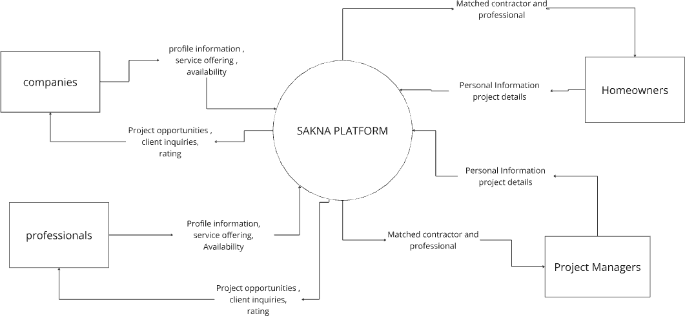

Figure 1: Context Diagram

The context diagram (see Figure 1 below) illustrates how SAKNA interacts with external entities including homeowners, project managers, contractors, and regulatory authorities, and how data is exchanged between the system and its users.

Use case Diagram
The use case diagram below (refer to Figure 2 below) shows the key functionalities of the SAKNA platform. It shows detailed actions that various users can perform within the system and how different actors interact with the platform to achieve their goals.

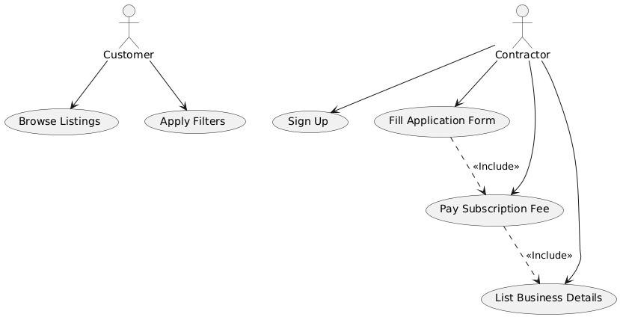
Figure 2: use Case Diagram

Activity Diagram
The activity diagram (refer to Figure 3 below) below shows the decision-making processes and system responses for activities carried out on the platform and shows a logical flow of these operations.

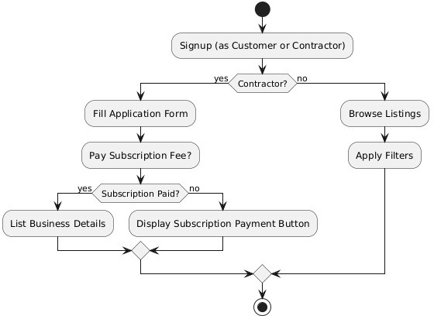
Figure 3: Activity Diagram

Sequence Diagram
Figure. 4 below is a sequence diagram of a typical user session that outlines the interactions between the various components making up the SAKNA platform. It presents in detail how the various actors and system components interact step by step; it goes further to specify the messages exchanged
inactions such as requesting contractor matches and receiving search results.

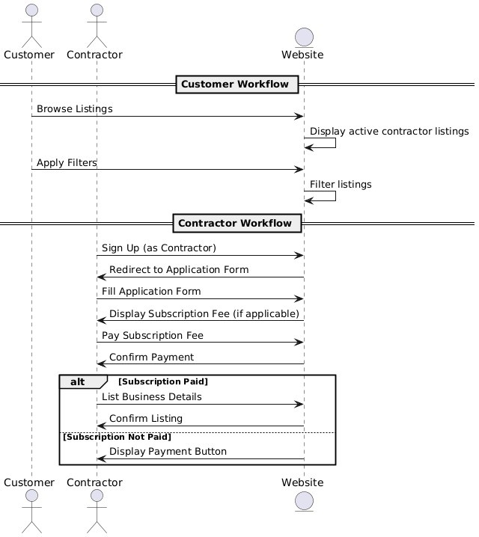
Figure 4: Sequence Diagram

ER Diagram
The Entity-Relationship diagram (refer to Figure. 5 below) represents SAKNA's data model, it shows the relationships between key entities like users, projects, contractors, and appointments.

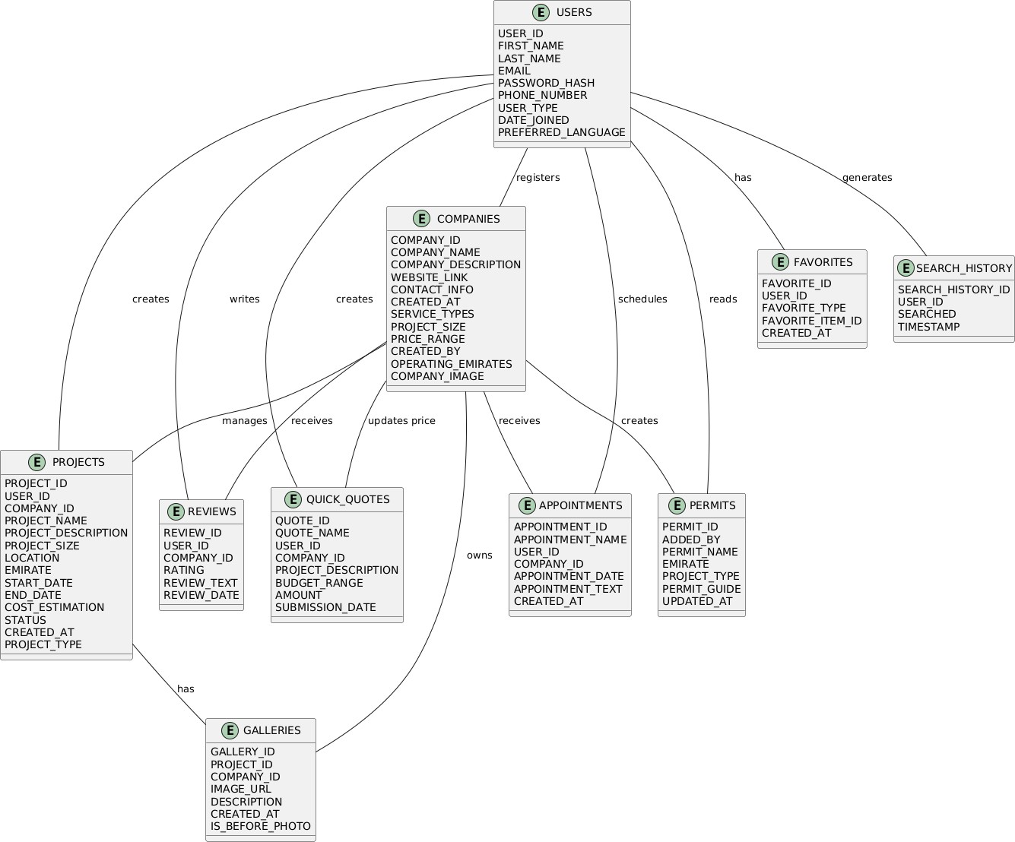

User Interface Design
SAKNA design focuses on creating a clean, simple, responsive, and easy-to-use user interface. This
design emphasizes usability, ease of use, and a clean user experience. This ensures that users can easily navigate through the platform and access all its features. The UI components are built using Bootstrap5 and jQuery UI, this provides a consistent look across different devices and operating systems.

Architectural Design

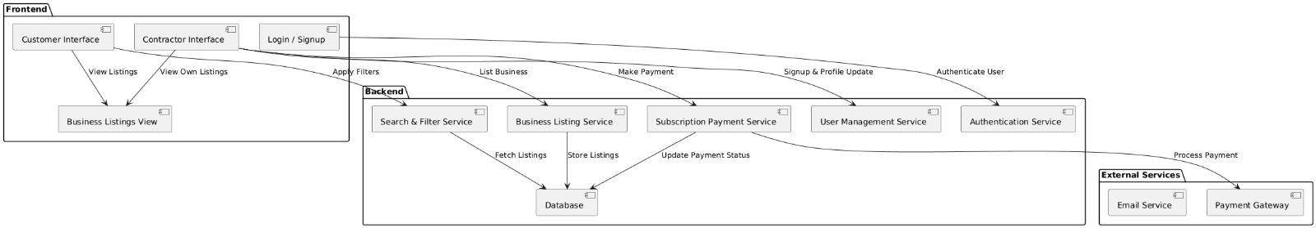
Figure 6: Architectural Design

SAKNA Architecture Model on Wix

The architecture of SAKNA will be the Layered Architecture Model molded into the development environment of Wix. The idea behind this would be to offer separation of concerns, hence scalability and maintainability, by maximum usage of built-in tools and services provided by Wix. The further development of the capability-based revised layered design for Wix is presented below.

Presentation Layer:
It involves the user-facing part, which is designed using Wix Editor tools and Wix Code.

This covers:
User Interfaces: The Wix drag-and-drop builder has made designing more intuitive, ensuring responsiveness. Inbuilt Wix themes make it consistent and interactive.
Custom Interactions: Velo scripts boost the potential of the site to deliver dynamic behaviors and enhance UI elements.

Mobile Optimization: It's automatically generated from Wix's responsive design capability.

Business Logic Layer:
This layer is responsible for the functional logic of the platform and, in Wix, implemented in Velo; hence, it allows the introduction of custom JavaScript code.
Key features include:
Matching of clients and contractors: Logics of automated matching using the dataset and filtering capability of Wix.
Estimation of cost: Calculations will be embedded via custom JavaScript in Velo.
Data Management: Dynamic interaction of UI with Wix databases using APIs from Velo.

Data Access Layer:
This layer is utilized for the interaction between business logic and the database with the help of the Wix Data APIs.
The key features are as follows:
Fetch and Store Data: Fetching and storing data using Wix's backend functions in a secured manner Prepared Statements: Automatically safe from SQL injection because Wix abstracts the database
layer

API Connectivity: In terms of integrating third-party services, Wix has HTTP functions that may handle RESTful API calls.

Database Layer:
Wix uses Cloud Storage as the database layer.

It comprises:
Structure Data: The major storage system is Data Collections in Wix.
Relationships between Data: It is done by using reference fields in order to simulate Entity- Relationship models.
Scalability: Wix itself scales and optimizes the databases. Integration with Third-party Services:
Email Notifications: Through Wix Automations or through integrations with third-party services

like SendGrid.
Payment Gateway: The use of Wix Payments or integrated third-party gateways that allow for seamless payment processing.

Network Design
SAKNA uses the whole stack of Wix and takes every user interaction efficiently along with data
transfer. Automate web servers on Wix, HTTPS with embedded SSL/TLS to encrypt data against any information breaches. User information shall be stored in the safest Data Collections at Wix, ensuring recoverability from backups against data losses. The platform assures perfect scalability, high
availability of systems, strong performance, and thereby facilitates the authentication of user identity in an easy manner by handling their permissions. The design ensures that users have a secure, fast, and
seamless experience.

Chapter Five: Implementation

Environment
SAKNA online platform was developed using a combination of robust, scalable and high-performance technologies and high-end development tools. Below is a list of technologies and development tools
that were used in the development of this platform:

Database System:
      - MySQL: This is a Relational database management system for storing and managing data. This platform used MariaDB 10.4.14 and MySQL 7.4.1.

Technologies:

- JavaScript: Used for custom scripting with Wix Velo and extra functionality. Enabled dynamic interactions along with backend logic.
- HTML: Applied on structure and layout, editor by Wix supported.
- CSS: Styles applied to provide a responsive and attractive User Interface.
- WIX code API: Database operations were performed, custom routing and authentication of users.
- JSON: Used for exchanging data between the platform and services or APIs if applicable. 3.Development:
Wix Editor:

- Used for designing and customizing the website interface. Having a drag-and-drop interface made building beautiful layouts quite easy.
- It also allowed custom development and scripting. Wix Velo:
  - Dynamic pages, interactions, and database connections can be implemented.
  - Dynamic management of content was also allowed. Wix Database:
    - Supported creation of custom collections for user data and other records. Wix App Market:
      - Additional functionality was possible with installing prebuilt apps, such as contact forms, chat support, or booking systems.
Integrated Tools:
- Integrated Tools: Improved the visibility of the site by optimizing its content for search engines.
- Allowed tracking of visitor data for decision-making.
- Payment Gateways: Allowed online transactions in a secure manner. Cloud Hosting Environment:
  - Wix in-built cloud hosting ensured reliability, scalability, and fast page load times.

Evaluation and Testing Measures

The evaluation and testing strategy for SAKNA was formulated to ensure that every component of the platform functions flawlessly, and all user interactions are smooth and error-free. The testing process focused on identifying any flaws early to guarantee a stable and high-quality final product.

Testing Goals
Testing in this project involved four major objectives, these objectives need to be met to ensure
operability and dependability of the platform. All features and components in the system needed to be working without error and be bug-free, the system was to be critically evaluated to ensure it was
reliable and that the cost estimation tool offered realistic estimates.

In addition, cross-browser compatibility and responsiveness tests were carried out to make sure that the platform delivered a consistent user interface on different devices, operating systems, and browsers.

The security aspect of the system was tested to guarantee protection of user data and make sure that sensitive information is never leaked.

Testing Plans
When developing this platform, a multilayered testing plan was adopted to make sure that various areas of the platform worked as intended, It was important to carry out unit testing where individual modules such as the cost estimator, contractor matching, and search filters were tested in isolation to make sure
that each component worked as intended. After each module was found to work as intended, integration testing was conducted to make sure that when the independent modules were combined, they worked together and the performance, security, and reliability of the system was tested.
After passing the aforementioned tests, user acceptance testing was carried out to make sure that users could access the platform and they embraced it. This ensured that all potential issues were captured
before the platform release.

Testing Methodologies
To make sure that SAKNA was reliable and offered quality services, the following testing methods
were employed throughout its development: The development team followed the industry-best coding practices such as writing modular, scalable, and maintainable code.
Regression testing was continuously carried out after every bug fix to make sure that the changes made to the code base did not introduce new issues or affect the existing functionality and performance. This was followed by security testing to make sure that the data transfer between various layers of the
platform was secure and that the system was proof against threats such as cross site scripting and SQL injection.

Implementation Schedule
The implementation plan to make sure SAKNA is on schedule and within the prescribed means phase by phase basing development on using the Wix platform shown below.
Sprint 0: Project Setup - weeks 1-2
This included an initial setup using the built-in tools within Wix. The structure of user and project appointment data was defined via Wix Data Collections, while the initial design of the website using Wix's drag-and-drop editor and custom functionality in Velo started.

Sprint 1: User Onboarding and Core Database (Weeks 3-4)

First sprint - the development of user profile management, design core database structure in Wix Data Collections in such a way to perform the core project management, setting up Wix's authentication
tools to manage the users' access.

Sprint 2: Matching System Contractor (Week 5-6)

Developed features: Contractor Profiles and Matching, built using Wix Dynamic Filtering. Core
functionality including basic cost estimation, reviews, search history - follow up improvements in iterative processes implemented with Velo.
Sprint 3: Feature Enhancement and Cost Estimation (Weeks 7-8)

Features included in this are enhanced cost estimation with region-specific data, multi-lingual support, permit guides, and favorites.
Wix Automation and Velo scripts come together to enable advanced user interactions and
functionalities. Sprint 4: System Testing & Performance Optimization Weeks 11-12 Testing for all, then bug fixing was performed. Performance optimization was also done by refining Velo scripts and
database queries.

Their feedback was very helpful in refining those features to make the experience better before the release.
The stage-by-stage schedule of implementation allowed SAKNA to deliver a robust, qualitative
platform with the power of Wix, which caters to the construction industry of the UAE while it's smooth and intuitive for homeowners and construction professionals.
User feedback was integrated into the platform to enhance functionality and overall performance. Sprint 5: User Acceptance Testing (Weeks 13-14)
The platform has been tested by a selected group of users to validate the ease of use and functionality.

By following this structured implementation schedule, SAKNA ensured a reliable, accurate and high- quality digital solution meeting specific UAE construction industry needs, with smooth experience for both homeowners and construction professionals.

Chapter Six: Conclusion

Strengths and Weaknesses
SAKNA has demonstrated several strengths that position it as a robust and innovative platform in the construction services industry.

Key strengths include:

    - Localized Focus: SAKNA, unlike its global competitors solely focuses on the UAE region making it take into account region-specific factors such as material cost, labor rates,
construction standards, and emirate-specific regulations, making the platform more effective.

    - User-Friendly Interface and Multilingual Support: SAKNA has multilingual support giving the users the ability to change between Arabic, Italian, French, German, and English. This plays a vital role in widening the platform's user base and enhancing accessibility.
    - Comprehensive Feature Set: This platform incorporates cost estimation, project management, favorites, quick quotes, search history and permit guidance, making it a one-stop solution for construction needs.
    - Security and Data Protection: SAKNA was built with security and privacy in mind. It boasts SSL/HTTPS encryption, data protection protocols, and secure user authentication, to protect
user information from unauthorized access and data breaches.

SAKNA just like any other online platform has its shortcomings, below are some of the weaknesses of this online platform:
    - Limited Market Presence: Being a new entrant in the market, SAKNA will initially struggle to capture a sizable market share in the UAE market as there is stiff competition from already
well-established competitors. This may make gaining the trust of users already accustomed to traditional methods of finding contractors challenging.
    - High Dependency on User Data and User Adoption: This platform matches homeowners and project managers with contractors based on the input data they provide, this makes the platform heavily dependent on user input, the platform’s matching algorithm therefore, is only as
effective as the user input is accurate. This platform also relies heavily on the willingness of contractors and clients to adopt it.

Improvements for the Future
To enhance the impact and reach of SAKNA, several improvements can be made in the next stages of development, these improvements include but are not limited to:
    - Technological Integration: Shortly, the system could incorporate AI, Virtual Reality, and
machine learning in matching algorithms to refine further the professional matching algorithm, cost estimation, and provide a personalized user experience.
    - Growing Construction Industry in the UAE: Since the UAE’s construction and real estate industry is rapidly growing, there is high potential for growth in digital construction solutions as more homeowners and project managers look for qualified professionals, therefore there is the
need to change to a more scalable technology like microservices in the future to accommodate the growing needs.
    - Expansion of Regional Focus: While the SAKNA online platform initially focuses on the UAE market, the platform could with time expand to serve the entire Gulf Cooperation Council
region, including and adapting to the specific requirements and regulations of neighboring countries.
    - Mobile Application Development: Soon, the development team could develop a dedicated mobile app to improve accessibility and engagement.

Conclusion
In conclusion, SAKNA is a major leap forward in modernizing how homeowners and contractors interact in the UAE construction sector. It addresses a clear market gap with a bespoke solution by
which it aspires to ease the burden of matching potential homeowners with the right professionals and provide tools that can make project planning, cost estimation, and adherence to regulatory requirements easier.
SAKNA’s strengths lie in its localized focus on the UAE market, user-centric design, and its advanced set of features not present or lightly emphasized on other online construction platforms, the platform's weakness spawns from the fact that it is a new entrant in the market and has an uncertain future as its
fate solely lies on market and user adoption.

SAKNA is a promising step forward in creating a centralized digital platform that will cater to all homeowner's and project managers project needs in the UAE. By focusing on aggressive marketing,
technological advancements and expanding its regional footprint, SAKNA has the potential to change how users and contractors interact online and become the leading digital platform in the construction industry that will change how construction projects are assigned and executed in the UAE and the Gulf cooperation council region.

Chapter Seven: References
- Wix building website
https://www.wix.com/
- W3Schools (n.d.). MySQL Tutorial. Retrieved from https://www.w3schools.com/mysql/default.asp
- jQuery Foundation (n.d.). jQuery Documentation. Retrieved from https://api.jquery.com/
- The Apache Software Foundation (2023). XAMPP [Version 8.2.3]. Retrieved from https://www.apachefriends.org/
- National Institute of Standards and Technology (NIST) (2020). Special Publication 800-63B: Digital Identity Guidelines. National Institute of Standards and Technology.
https://pages.nist.gov/800-63-3/

- Smith, J. (2020). Building Efficient Construction Systems. Engineering Today Publications.
- Houzz Pro (2022). Features of Modern Construction Platforms. Retrieved from https://www.houzz.com/pro.
- Thumbtack. (n.d.). Home Page. Retrieved from https://www.thumbtack.com.
- Brown, T., & Green, M. (2019). Cost Estimation Techniques for the Digital Age. 2nd Edition, Urban Design Publishers.
- PlantUML. (2023). Open-source tool to create UML diagrams from plain text descriptions. Retrieved from https://plantuml.com.
- U.S. Department of Commerce, International Trade Administration. (2023, November 25).
United Arab Emirates - Design and Construction Project Opportunities. Retrieved from https://www.trade.gov/united-arab-emirates.
- Mordor Intelligence. (2024). UAE Construction Market - Industry Outlook, Statistics & Size. https://www.mordorintelligence.com/industry-reports/uae-construction-market

Chapter Eight: Appendix

Running the System
To run the system on a local machine, the SAKNA system can be accessed from any browser on the local machine by following the following link:
https://www.sakna.net/

To access the system, the user should navigate to and use the credentials below:

Homeowner/contractor Login
Email:nadafarajalla@gmail.com Password:nada1234567

Professional Login
Email: rowdahamdan5@gmail.com Password:Rowda@213113

Screenshots
Below are screenshots of the developed platform8.2.1. Homepage:

Figure 7: Homepage Screen

The sign in screen

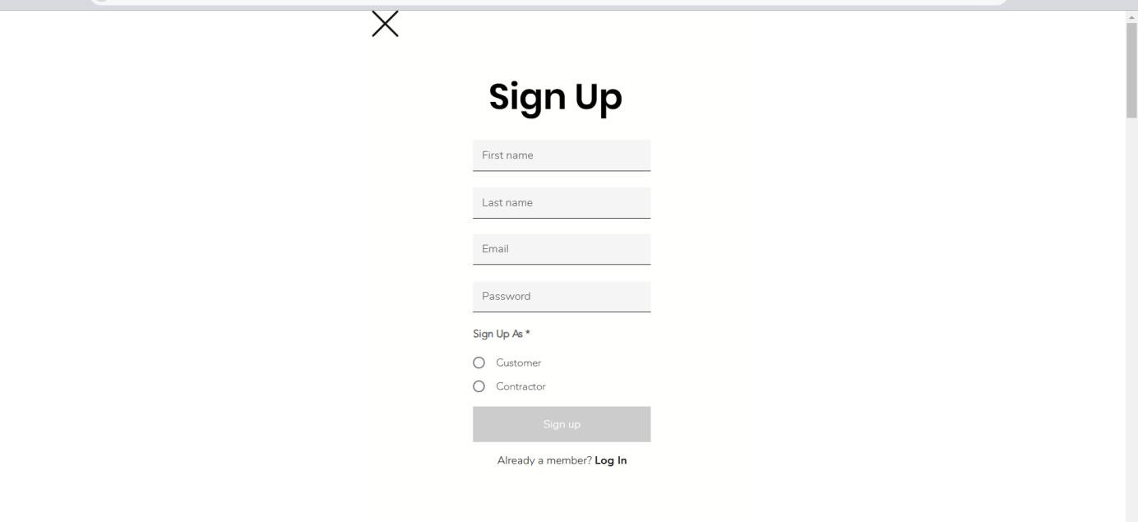
Figure 8: Sign in Screen

Dashboard
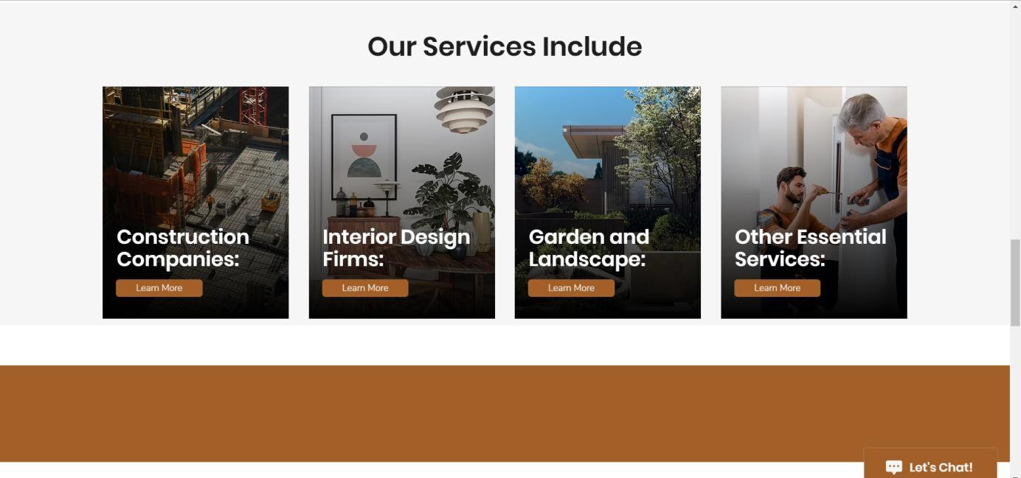

Figure 9: Dashboard

8.2.4 Sign in (constructor )
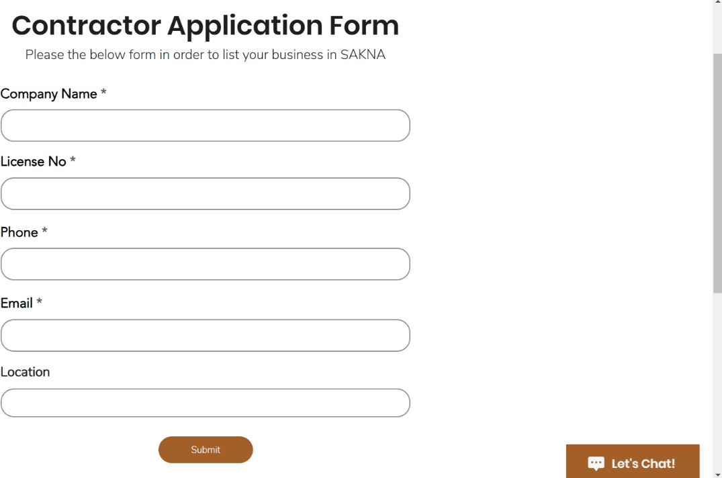
Figure 10: Sign in (constructor )

8.2.5 My Account
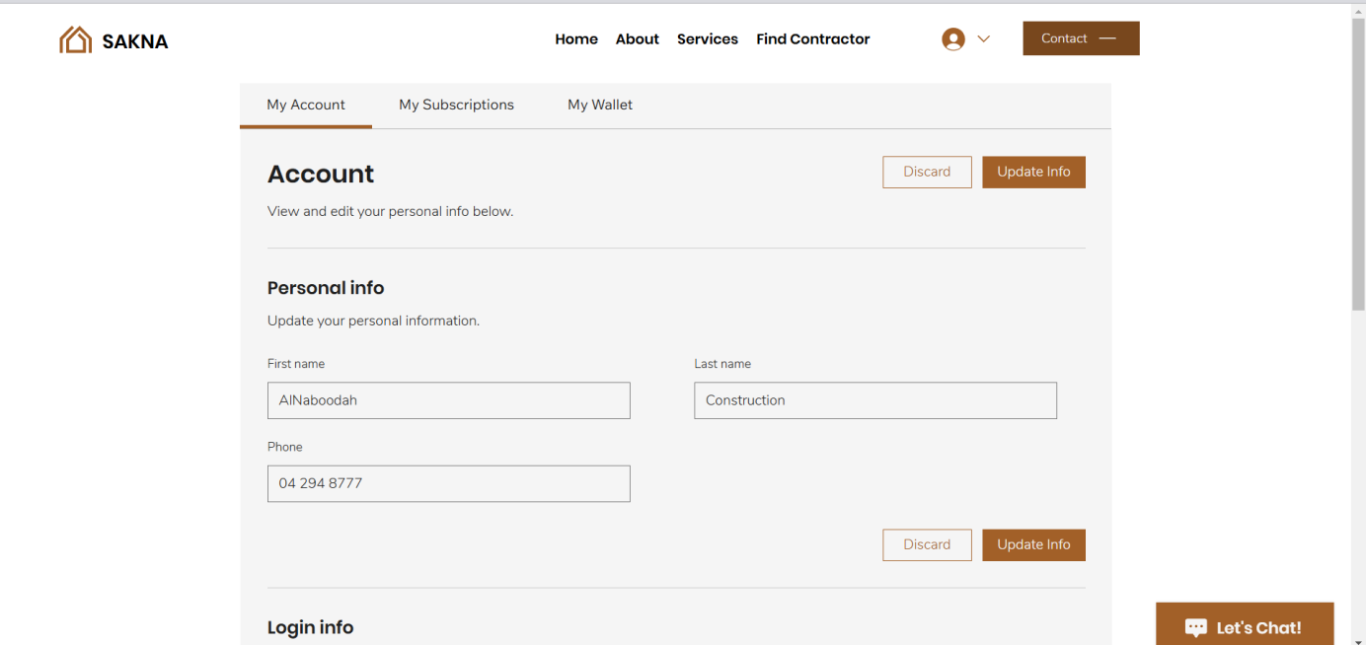
Figure 11: My Account

